# Notes on system for Time Sheet capture

## Homes Screen and MDI (this is for ongoing development information)

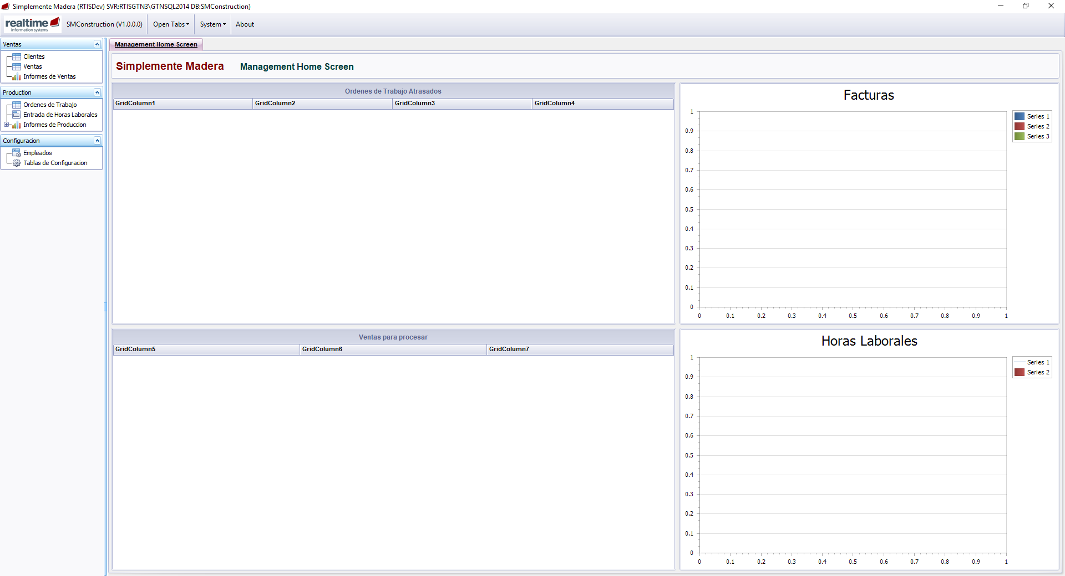

The idea of the home screen is to give each user a view of the key tasks that they should be addressing and some relevant KPI’s. The home screens are designed around different roles, so that different staff have the relevant information for their specific role

The menus on the left give you access to the other areas of the system. These can be managed with user permissions, so different groups of users are only presented with the areas of the system that are relevant for their roles.

The application is a “Multiple Document Interface”. This means that you can open many pages at once (e.g. have two OT details pages open at the same time as a report and a Purchase Order.

## Elements Required for the Time Sheet Tool

### Employees

Minimal information required at the moment

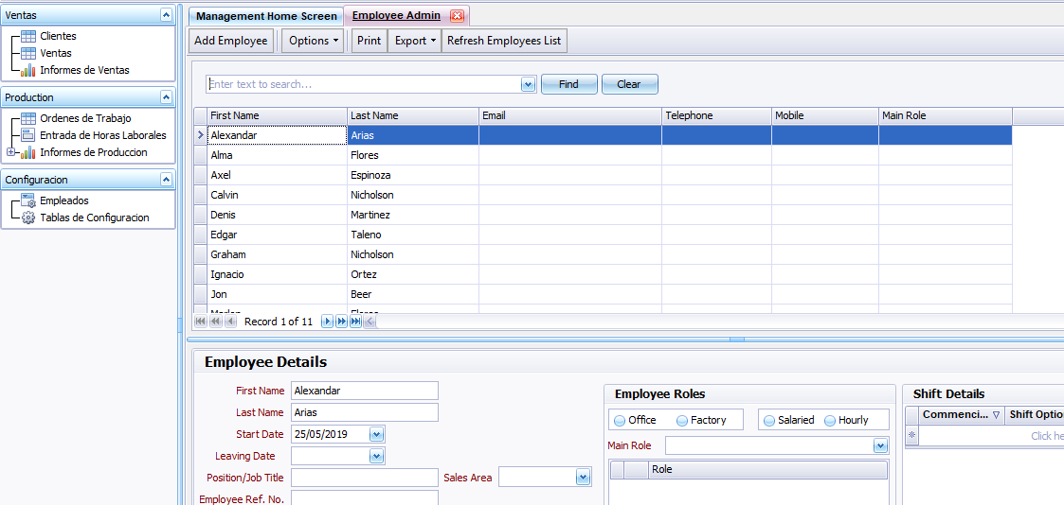

### Ordenes de Trabajo

Again, minimal information required at the moment

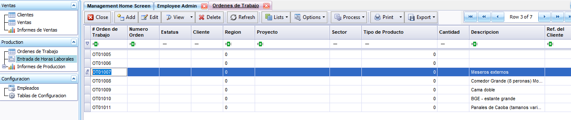

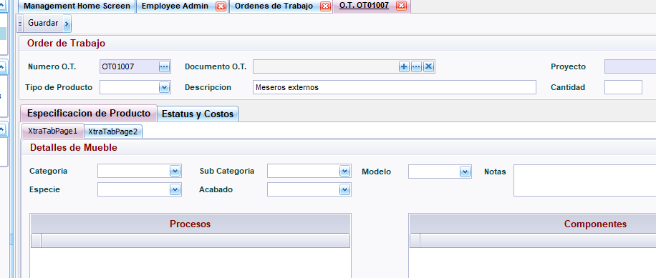

The system should be used to Raise the OT Number. (the button … does this)

### Time Sheet Entry

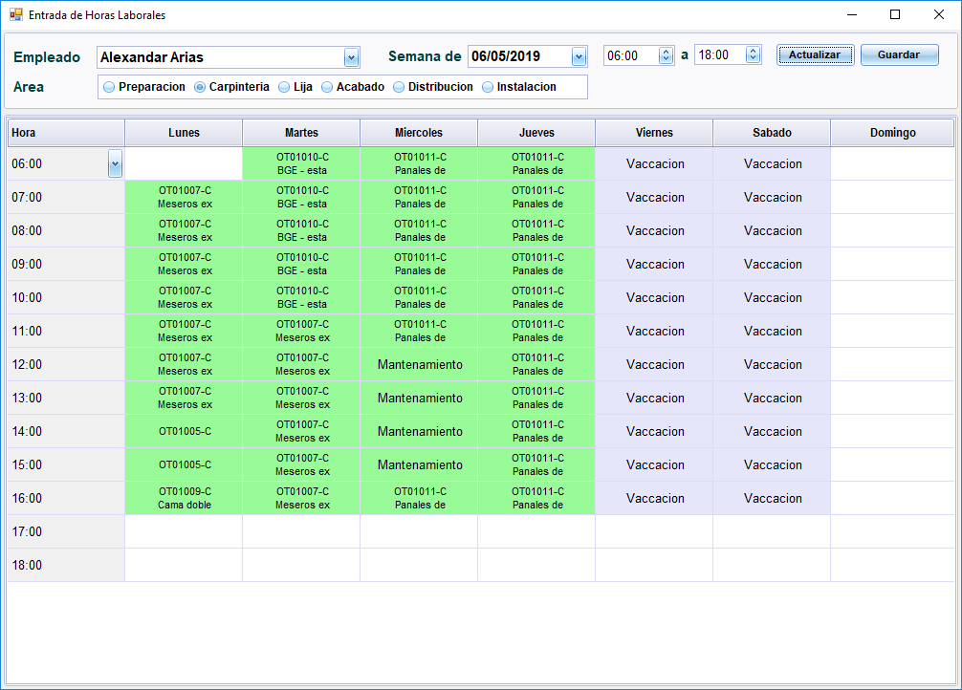

The idea with this form is to make entry as quick and easy as possible. It is not 100% correct yet, but we are trying to incorporate the following features

* First select the Employee, the Area of work (can be changed if the employee moves around during the week) and the Week Commencing date.
* Typing a number in a cell and hitting return (e.g. 1007) looks for that O.T. and if it finds it adds detail (the -C shows that this work was in the area of Carpinteria)
* You don’t need to fill in all the cells. If after filling in Lunes 07:00, the user puts the same job in at 13:00, then the system assumes that you want to cover that range with this job.
* Entering a letter code associates the time with a task other than OT (M = Mantenamiento, A = Absencia, V= Vacaccion, L=Limpieza). Again the first and last entries of the span can be entered and the application fills in the range.

## Analysis

### Details within the OT

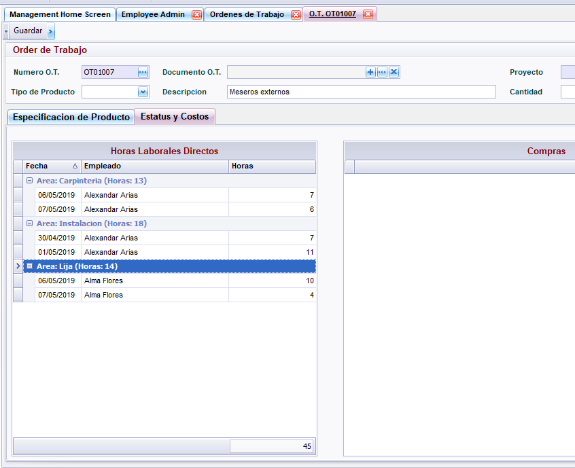

The time accumulated against the OT shows in the details page of the OT

We have provided a mock up grid in the OT details for where you could provide the expected hours per areas for an OT. Once we are capturing the actuals, it may be a good next step to enter the expected capacities required so that this feeds into the analysis and we will be able to see where you are underestimating/overestimating the time required for the different types of product.

### Lists and Pivots

In the Reporting Section there is options flexibly analyse the data (always with excel export options as well). All Pivot grids have drill downs.

